ZERO DAY ATTACK DETECTION AND PREVENTION

_{Padmashani R}  _{Assistant Professor [Sl.Gr.]}  Dept.of Information Technology PSG College of Technology Coimbatore, India  _{rpi.it@psgtech.ac.in} | _{Jemi Wilson P}  _{Dept.of Information Technology}  PSG College of Technology Coimbatore, India  22i227_{@psgtech.ac.in} | _{Keerti N}  _{Dept.of Information Technology}  PSG College of Technology Coimbatore, India  22i229_{@psgtech.ac.in}

_{Nandhini I}  Dept.of Information Technology PSG College of Technology Coimbatore, India  22i235_{@psgtech.ac.in} | _{Shahnaz SM}  Dept.of Information Technology PSG College of Technology Coimbatore, India  22i254_{@psgtech.ac.in}

Abstract- Zero-day​‍​‌‍​‍‌​‍​‌‍​‍‌ attacks are among the most dangerous issues facing modern cybersecurity. They exploit security vulnerabilities that are unknown and thus cannot be patched. A traditional signature or rule-based Intrusion Detection System (IDS), or any fixed rules, will generally not be able to detect such types of attacks. In this paper, we propose a hybrid deep learning-based zero-day attack detection and prevention framework that comprises Deep Autoencoder (DAE), Causal Recurrent Network (CRN), and CatBoost. These components work together to perform anomaly detection and classification of the highest quality. The paper explains that the DAE and CRN coordinate their efforts to identify the structural and temporal features of the network traffic and, therefore, arrive at a single fused anomaly score, which is very sensitive to the new behaviors of the network. In addition, the CatBoost model identifies the attack vectors that the system already knows and thus can detect and, at the same time, it also identifies the zero-day vectors by using the centroid distance analysis. The whole system is designed and implemented in a scalable master-client deployment architecture mode where distributed client nodes are responsible for live traffic capturing and a central master node performs the detection in real-time and the prevention actions such as IP blocking can be executed automatically.

Keywords: Zero-day attack, Intrusion detection, Deep learning, Autoencoder, CatBoost, CRN, Anomaly detection.

1. INTRODUCTION
The​‍​‌‍​‍‌​‍​‌‍​‍‌ fast changes of digital infrastructures together with a multitude of interconnected devices have made networks the target of very sophisticated and hard-to-detect cyberattacks. Among such attacks, zero-day attacks are the most difficult problems in network security. A zero-day exploit is a targeted attack on a software or hardware vulnerability that is unknown even to the vendor and thus no patch or signature has been released, which means that the attacker can operate in the targeted system without being detected. These types of attacks elude security solutions, which are based on static rules or predetermined attack signatures. Because of that, usual Intrusion Detection Systems (IDS) and antivirus mechanisms are not timely enough to identify and neutralize these attacks.
Owing to network traffic being ever-changing and attack patterns previously never seen, the detection methods used also must be intelligent and adaptive. The use of ML and DL methods in network security brings about a significant change in that behavior-based anomaly detection can now be used in place of signature-based detection. These models monitor normal network activities and are able to detect very subtle deviations in which malicious activity is hidden, thus, they can also identify threats hitherto unknown, whereas traditional IDS do not have this capability.
Nevertheless, ML-based IDS that are currently available have some serious drawbacks. The biggest challenge for these researchers to overcome is that unsupervised models sometimes generate false alarms and supervised classifiers require large extensive datasets. In addition, the majority of deep models have difficulties in capturing the sequential dependencies of network occurrences and functioning efficiently in decentralized, real-time settings. These loopholes highlight the necessity for a self-learning, scalable, and hybrid system that can detect both known and unknown intrusions with a short time delay.
Our solution to these problems is a Hybrid Deep Learning-based Zero-Day Attack Detection and Prevention Framework with three essential components: a Deep Autoencoder (DAE) for detecting anomalies in structures, a Causal Recurrent Network (CRN) for analyzing the temporal sequence, and a CatBoost classifier for supervised threat classification. The integration of DAE and CRN anomaly scores facilitates detection at a more granular level while the rate of false positives remains low. The adoption of centroid distance thresholding makes it possible for one to discover that even in a cluster of normal activities, there is still a zero-day intrusion. In addition, traffic monitoring in several places, decision-making at one place, and intrusion prevention that is automated, like IP blocking or node isolation, are all supported through the use of master-client architecture which, by the way, is also part of this framework.
The designed framework is intended to be a first line of defense, a security system that is user-scalable and constantly changes as new threats arise while at the same time it is able to detect and repel zero-day attacks in ​‍​‌‍​‍‌​‍​‌‍​‍‌real-time.

2. RELATED WORK
Recently,​‍​‌‍​‍‌​‍​‌‍​‍‌ the intrusion detection and network security researches have stressed more and more the need for intelligent and adaptive models that can detect both known and unknown (zero-day) threats. Conventional Intrusion Detection Systems (IDS) are mainly based on signature-based mechanisms, which check the incoming traffic against the signatures of the known attacks that are stored in the database. These methods are very precise when it comes to the detection of threats that have already been cataloged; however, they are incapable of discovering new exploits that have not been recorded in the vulnerability databases. In order to solve this problem, a vast number of researchers have turned to machine learning and deep learning methods for anomaly-based intrusion detection. The paper presented in the journal Concurrency and Computation: Practice and Experience [1] outlined an ensemble classification methodology that merges several supervised learning models to perform zero-day attack detection. The ensemble classifier achieved a higher level of detection accuracy than the single classifiers; however, the authors pointed out that the ensemble's computational complexity was very high, thus, it cannot be easily deployed in real-time in large networks. Sarhan, Layeghy, and Portmann [2] examined the possibility of using Zero-Shot Learning (ZSL) in Intrusion Detection. Their method involved transferring the knowledge gained from the attacks classes already learned to the detection of the newly ones, and thus, they showed potential in the identification of new intrusion patterns. However, the ability of the model to generalize fell drastically when it was faced with the attack patterns that were completely different from the previously known ones, thereby limiting the model's effectiveness in the case of the most highly novel zero-day exploits. The unsupervised method detailed in IET Networks [3] utilized a combination of autoencoders and clustering techniques to identify malicious behavior without the need for labeled data. While the method was able to achieve moderate levels of accuracy with unlabeled traffic, the lack of supervised calibration resulted in a high false-alarm rate, thus, the method's reliability in production environments was low. The research published in IEEE Access [4] suggested a CNN-based anomaly detection system for physically constrained Internet-of-Things (IoT) environments. By employing convolutional layers with L1/L2 regularization, the device achieved good classification power; however, the limited resources available on IoT nodes made such deep structures nonviable for real-time operations. At the journal Security and Communication Networks [5], the authors released a paper on a sandbox-based malware detection approach that used ML classifiers trained on behavioral data obtained from virtual environments. Although the technique was very precise, the execution of sandbox was resource-heavy and, thus, not suitable for large-scale or time-sensitive scenarios. Researchers have explored the potential of semi-supervised models as well to diminish the demand for labeling. An article in IEEE Access [6] experimented with clustering and minimal supervision to identify zero-day attacks with very few labeled instances. While progress was made in adapting to new threats, the model gave out noisy traffic conditions as its weakness and thus false-positive ratio increased while being inconsistent in scenarios of noisy traffic. Dahal et al. [7] experimented with the use of Explainable Artificial Intelligence (XAI) in combination with multilayer perceptron (MLP) structures so as to provide clear explanations of intrusion detection decisions. The research results addressed the issue of transparency but posed problems of scalability and speed for large datasets. In the subsequent research [8], the authors integrated attention-based fusion with XAI thus enhancing the precision of the system but also increasing the computational resource requirements hence the feasibility of real-time deployment is limited. Guo [9] revisited quite a number of Machine Learning-driven zero-day detection methods and came up with a research agenda for Intrusion Detection Systems that emphasizes the need to take into account not only the accuracy but also interpretability, scalability, and computational cost. The survey pointed out that none of the existing models can be regarded as a single, hybrid solution that can keep the detection accuracy at a very high level and still have low latency and being flexible when it comes to ​‍​‌‍​‍‌​‍​‌‍​‍‌deployment.

3. SYSTEM DESIGN AND ARCHITECTURE
The​‍​‌‍​‍‌​‍​‌‍​‍‌ Zero-Day Attack Detection and Prevention Framework proposal envisioned a revolutionary, scalable, and self-regulating IDS that basically integrated structural, temporal, and supervised learning elements cohesively. Its main architecture spans across the modules of Deep Autoencoder (DAE), Causal Recurrent Network (CRN), CatBoost Classifier, and a Master–Client Communication Layer which collectively work to provide a foolproof network security system.
The DAE is essentially a structural anomaly detector. It employs autoencoder to differentiate between the normal and abnormal network traffic. Thus, it internally compresses (encodes) the input features to their a brief latent form and then decompresses (decodes) the brief representation to calculate the reconstruction error. Large discrepancies between the original and the recreated versions point to the anomalous network behavior which can be an intrusion attempt. It doesn't rely on simple detection methods but instead looks at the deeper inter-feature interactions thus significantly improves early detection rates of deviations of which even IDS fail to spot usually.
The CRN captures the temporal characters of the network flows employing Long Short-Term Memory (LSTM) units. Basically, it anticipates the subsequent series of network behaviors and if there is a quite substantial difference between the expected and the observed sequences, an abnormality is reported. Such time-series examination enables the CRN to pinpoint the rarest type of attacks - context-based, like a coordinated scan or slow-burn exploit that unfolds gradually over time.
The two network intrusion detectors, DAE and CRN, have their outputs merged by weighted fusion, which, in turn, gives a single whole anomaly score indicative of deviations both structural and temporal. A moving average of recently observed events and some other statistics are used to adapt the threshold that dynamically evaluates the fusion score. This scoring approach limits false alarm rates while keeping the system alert to new attack patterns.
Once an anomaly is found, the CatBoost classifier moves on with supervised attack categorization. The classifier trained on labeled attack data easily separates classes of attacks that the network faces regularly, e.g., DoS, DDoS, and Botnet. Whereas, if the anomaly lies far from the zero-day attacks cluster center, it is identified to be new ones. Moreover, CatBoost’s gradient-boosted decision tree algorithm is highly efficient in dealing with hybrid categorical–numerical data and at the same time, it generates interpretable feature importance metrics that can be used for providing explanations to the detection results, thus, transparency is improved.
This system follows a scalable and real-time monitoring distributed master–client architecture pattern. A client node is responsible for recording local traffic via tools like Wireshark or TShark, preprocessing it shortly, and then securely sending the feature vectors to the master node.
The DAE–CRN–CatBoost pipeline is run by the master node on the input data, which is in turn gathered from several clients, together with the anomaly outcomes, and preventive steps like IP blocking or source isolation are thus, triggered automatically. This design facilitates separate deployment modules that can spread across enterprise or cloud environments ensuring that while sensing is distributed; analysis is centralized.

4. METHODOLOGY
The methodology of the proposed Hybrid Zero-Day Attack Detection and Prevention System focuses on building an intelligent, adaptive, and scalable framework that identifies unknown intrusions and automatically responds to them in real time. The implementation pipeline is divided into multiple stages: data collection and preprocessing, model training (DAE, CRN, and CatBoost), fusion-based anomaly detection, and
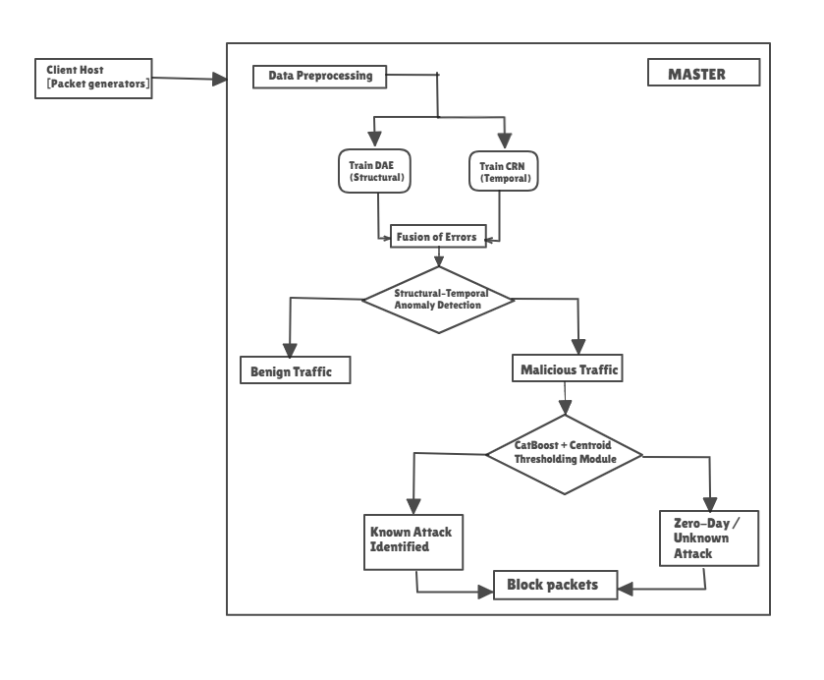
Fig .1. Block diagram of the proposed Zero-Day Detection and Prevention framework.

deployment in a master–client configuration.
4.1 Data Collection and Preprocessing
To ensure model reliability and generalization, the system combines both benchmark datasets and live traffic data. Public dataset like UGRansome was used for structured attack samples, covering various threat categories including DoS, DDoS, PortScan, Botnet, and Brute-force. Simultaneously, real-time benign traffic was captured using Wireshark and TShark across distributed client nodes to simulate normal enterprise behavior.
Each captured packet flow was converted into fixed-length records containing statistical and behavioral features such as packet count, duration, source–destination bytes, flag counts, and protocol type.
Preprocessing steps included:
- Feature Mapping: Aligning heterogeneous datasets under a unified 14-feature schema.
- Encoding: Converting categorical attributes (e.g., protocol, service) into numerical form via one-hot encoding.
- Normalization: Scaling continuous features using Min–Max or Z-score normalization to prevent large-value bias.
- Sequence Formation: For CRN training, flow records were grouped into temporal sequences of 10–20 time steps.
- Balancing: Attack classes were balanced using random undersampling to reduce class imbalance.
This stage ensures high-quality, standardized data that improves model convergence and reduces false alarms during inference.
4.2 Deep Autoencoder (DAE) Training
The Deep Autoencoder (DAE) serves as the structural anomaly detector. It learns compact latent representations of normal traffic by minimizing reconstruction error between input and output vectors.
The DAE consists of three encoding layers (128–64–32 neurons) followed by symmetric decoding layers (64–128 neurons) with ReLU activation, and a linear output layer for reconstruction. The Mean Squared Error (MSE) loss function is minimized using the Adam optimizer.
Training was conducted for 100 epochs with early stopping to prevent overfitting. The reconstruction error $E_{DAE}=∣∣x-\hat{x}∣∣^{2}$is used to identify anomalies. A dynamic threshold $T_{DAE}=μ+3σ$separates normal and abnormal traffic, where $μ$and $σ$represent the mean and standard deviation of the error distribution on benign samples.
This model effectively learns structural deviations such as abnormal packet counts or sudden spikes in flow features.

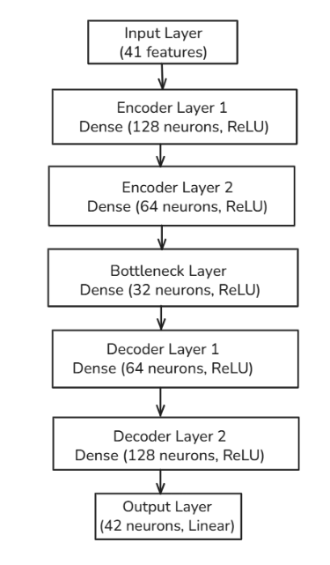
Fig 2. DAE Workflow

4.3 Causal Recurrent Network (CRN) Training
The Causal Recurrent Network (CRN) extends anomaly detection to the temporal domain. It is based on Long Short-Term Memory (LSTM) architecture, which captures sequential dependencies in network activity.
The CRN receives sequences of normalized features and predicts the next time-step behavior. It contains one LSTM layer with 256 hidden units followed by a fully connected output layer. The MSE loss is again used to train the network on normal traffic sequences.
Prediction deviation is calculated as $E_{CRN}=∣∣y_{pred}-y_{true}∣∣^{2}$, and anomalies are identified when this exceeds a threshold $T_{CRN}=μ+3σ$. The CRN detects context-dependent anomalies such as multi-stage intrusions or temporal shifts in packet flow that static models cannot capture.
Both DAE and CRN models are trained independently and saved as inference modules for deployment.

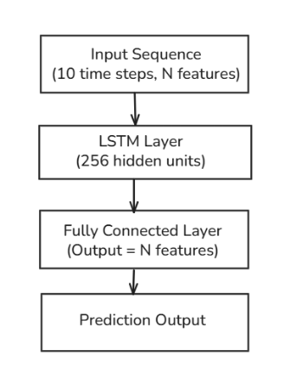

Fig 3. CRN Workflow

4.4 CatBoost Classification and Centroid Distance Thresholding
For classification of detected anomalies, the CatBoost algorithm—a gradient-boosted decision tree model—is employed. CatBoost efficiently handles categorical and continuous features without extensive preprocessing.
The model is trained on labeled attack data extracted from CIC-IDS2017 and UGRansome datasets using an 80:20 train–test split. Key hyperparameters include:
- Iterations: 1000
- Learning rate: 0.05
- Depth: 8
- Early stopping rounds: 50
The trained classifier achieves 95.4% accuracy, identifying attack classes such as DoS, DDoS, Infiltration, and Botnet. For zero-day detection, the Centroid Distance Thresholding technique is applied. Each known attack cluster’s centroid in feature space is computed, and test samples with distance greater than a defined threshold are labeled as unseen (zero-day) attacks. This allows the system to detect novel attack types beyond the scope of the training data.
4.5 Fusion Algorithm
To improve overall detection reliability, the framework fuses the outputs of DAE and CRN using a weighted anomaly score.
$$S_{fusion}=α×E_{DAE}+(1-α)×E_{CRN}$$
where $α$is the fusion weight (typically 0.6 for DAE and 0.4 for CRN).
The adaptive threshold $T_{adaptive}$is computed as a combination of moving average and percentile-based statistics from recent network windows. If $S_{fusion}>T_{adaptive}$, the sample is flagged as anomalous and forwarded to the CatBoost classifier for further analysis. This fusion approach enhances sensitivity to both instantaneous and time-evolving threats while minimizing false positives.
  - Client–Master Deployment
The proposed model operates within a distributed master–client architecture to enable real-time monitoring across multiple network nodes. Each client node captures live network traffic using packet sniffing tools such as Wireshark, performs preliminary preprocessing including feature extraction and normalization, and transmits the resulting feature vectors securely to the central master node via RESTful APIs or socket-based communication. The master node executes the complete DAE–CRN–CatBoost inference pipeline, applying fusion-based anomaly detection and classification to determine whether the observed traffic represents benign, known attack, or zero-day behavior. Upon detection of a malicious or zero-day event, the master system initiates an automated prevention response by updating firewall rules, blocking suspicious IP addresses, or isolating the compromised source node from the network. All detection outcomes, timestamps, and packet logs are recorded for continuous analysis, auditing, and retraining. This logging mechanism enables the framework to evolve dynamically with emerging threats, ensuring adaptive learning and maintaining high detection accuracy in distributed and large-scale network environments.

5. EXPERIMENTAL SETUP
To​‍​‌‍​‍‌​‍​‌‍​‍‌ demonstrate the capabilities of the hybrid framework, various experiments were performed. The authors built a thorough experimental environment including the stages of hardware, software, and dataset preparation. All the model development and testing were done in a controlled setup to maintain the result's reproducibility. The authors ran experiments in a Google Colab environment with Python 3.10 and the following libraries: TensorFlow 2.15, PyTorch 2.0, Scikit-learn 1.3, NumPy, and Pandas. GPU acceleration was available with an NVIDIA Tesla T4 unit that could provide 16 GB of video memory for the parallelization of deep-learning computation. The base host was made up of an Intel Core i7 (11th Gen) processor, 16 GB DDR4 RAM, and 256 GB SSD storage running on Ubuntu 22.04 LTS. Client nodes for master–client simulations were set up on the other systems with Windows 11, and they were connected via a local area network (LAN) with an average latency of fewer than 10 ​‍​‌‍​‍‌​‍​‌‍​‍‌ms.
The dataset used was UGRansome. Network traffic were also recorded live with the help of Wireshark and TShark. In total, these sources contributed to a dataset that contains over two lakh labeled network flow records depicting a wide variety of normal and malicious behaviors. Before the training, the data was thoroughly preprocessed with the steps of encoding, normalization, and class balancing to make sure that the samples were consistent. There was an 80% - 20% split for the dataset, the training was done on the first part, and the second one was used for validation and testing, hence the evaluation was kept fair and unbiased.

System Requirements | Master System | Client Systems
Processor | Intel Core i5/i7 | Intel Core i3
RAM | Minimum 8 GB (16 GB recommended for real-time processing) | 4 GB minimum
Storage | SSD with at least 50 GB free | 20 GB
Network | Ethernet/Wi-Fi (LAN recommended for faster log transfer) | Basic connectivity to send logs to master
Table 1. Hardware Requirements

5.1. RESULT ANALYSIS
The​‍​‌‍​‍‌​‍​‌‍​‍‌ performance of the proposed Hybrid Deep Learning Framework was put through a rigorous test using both benchmark datasets and live traffic data. The findings showcase the model's ability to pinpoint in a highly accurate manner not only familiar but also zero-day intrusions, and at the same time, keep the false-positive rates at a minimum and be responsive in ​‍​‌‍​‍‌​‍​‌‍​‍‌real-time.
5.2 Performance Metrics
The proposed framework was evaluated using standard classification metrics — Accuracy (ACC), Precision (P), Recall (R), and F1-score (F1) — along with False Positive Rate (FPR) to measure reliability. The metrics are defined as:
$$Accuracy=\frac{TP+TN}{TP+TN+FP+FN}$$
$$Precision=\frac{TP}{TP+FP}$$
$$Recall=\frac{TP}{TP+FN}$$
$$F1=2×\frac{Precision×Recall}{Precision+Recall}$$
where $TP$, $TN$, $FP$, and $FN$denote true positives, true negatives, false positives, and false negatives, respectively.
5.3 Model Performance
The​‍​‌‍​‍‌​‍​‌‍​‍‌ hybrid system was able to detect with high accuracy and also generalize well to different types of attacks that were both known and unknown. Deep Autoencoder (DAE) was the most effective component with a reconstruction accuracy of 98.8% showing that it learned the normal network structure very well. The Causal Recurrent Network (CRN) got a 99.7% prediction accuracy, which means that it was able to identify the temporal dependencies in the network flows. The CatBoost classifier achieved 95.4% of the classification accuracy, which is better than the traditional machine learning baselines such as SVM and Random Forest. As a result of combining the components through the fusion mechanism, the system was able to achieve an overall accuracy of 96.2%, a precision of 94.5%, a recall of 95.8%, and an F1-score of 95.1%. The false-positive rate was brought down to 2.6%, which is a 17% betterment with respect to deep learning models used separately. These findings serve as evidence that the performance of an IDS can be significantly enhanced and the number of misclassifications reduced by integrating structural and temporal anomaly detection with supervised ​‍​‌‍​‍‌​‍​‌‍​‍‌classification.

5.4 Zero-Day Detection Evaluation
A​‍​‌‍​‍‌​‍​‌‍​‍‌ zero-day simulation experiment was conducted to check the framework’s capability to identify intrusions that it had not seen before. In each iteration, one type of attack (e.g., Infiltration, PortScan, or Botnet) was left out during the training phase and later used during testing. Random Forest and SVM as examples of traditional models, treated these new samples as normal, resulting in a detection rate of less than 60%. On the other hand, the hybrid model proposed was able to achieve a mean zero-day detection rate of 92.6% due to its fusion-based anomaly scoring and centroid distance thresholding method. The DAE and CRN components spotted changes in the data distributions that were not previously seen, while CatBoost was able to differentiate these from the known attacks. This test is a proof to the framework’s strong generalization and its capability of being able to change with the behavior of threats which is a feature that is very vital for the present-day cybersecurity ​‍​‌‍​‍‌​‍​‌‍​‍‌systems.

Model | Optimization  Criterion | Epochs | Accuracy
DAE | MSE | 60 | 98.82%
CRN | MSE | 65 | 99.70%
CatBoost Classifier | MultiClass Log Loss | 999 iterations | 95.4%
Table 2. Model Training Metrics

5.5 Real time Client-Master Performance
The​‍​‌‍​‍‌​‍​‌‍​‍‌ combined system was installed in a multi-host setting with one master and three client nodes. Client machines were capturing the traffic non-stop and sending the preprocessed feature vectors to the master node through secure FASTAPIs. The master node was doing the DAE–CRN–CatBoost inference and, in addition, it was activating the automated responses for the detected attacks. On average, the detection latency was around 1.2 seconds per flow, and thus, the total end-to-end detection and prevention time was under 3 seconds. The device was writing firewall rules on the fly to block the malicious IPs, and therefore, no time was wasted in responding to the threats. The resource usage was kept at a good level, with less than 3 GB of RAM being utilized, and the inference time was quite stable even in the case of heavy traffic. Such results serve as a confirmation of the proposed system deployment capability both in enterprise and IoT scenarios where continuous monitoring and immediate intervention are a ​‍​‌‍​‍‌​‍​‌‍​‍‌must.
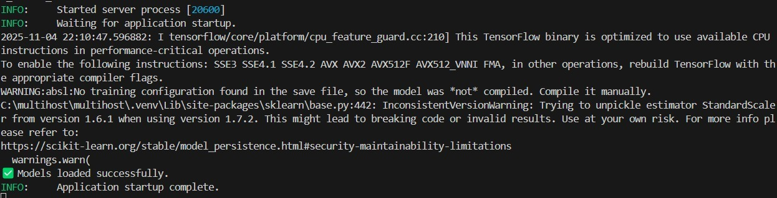
Fig 4. Server setup
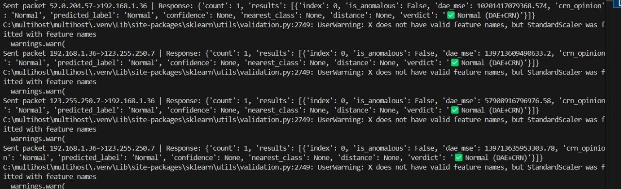
Fig 5. Packet transmission log showing anomaly detection and classification results

5.5 Outcomes
The experimental evaluation yielded significant outcomes, demonstrating the system’s effectiveness in zero-day detection through the fusion of the DAE and CRN models, which achieved high anomaly detection accuracy while reducing false positives. The CatBoost classifier exhibited strong generalization capabilities by accurately classifying known threats and flagging previously unseen network traffic as potential zero-day attacks. Additionally, the scalable client–master architecture proved efficient for real-time detection across multiple nodes, ensuring minimal computational overhead and seamless deployment in distributed environments.

6. REFERENCES
[1] Moustafa, N., & Slay, J. (2020). Ensemble classification for detecting zero-day attacks in network traffic. Concurrency and Computation: Practice and Experience, 32(17), e5406. https://doi.org/10.1002/cpe.5406
[2] Sarhan, M., Layeghy, S., & Portmann, M. (2022). Zero-shot learning for network intrusion detection: A comprehensive evaluation. Computers & Security, 120, 102788.

[3] Kumar, S., & Singh, R. (2021). Unsupervised anomaly detection using autoencoder and clustering for network intrusion detection. IET Networks, 10(4), 200–210.
[4] Li, H., Zhang, X., & Wang, J. (2021). Lightweight CNN-based anomaly detection for IoT devices under resource constraints. IEEE Access.
[5] Bansal, A., & Sharma, S. (2020). Sandbox-based malware detection using machine learning classifiers. Security and Communication Networks,2020,1–12. https://doi.org/10.1155/2020/7638254
[6] Al-Abassi, A., & Anwar, Z. (2021). Semi-supervised intrusion detection using clustering and minimal supervision. IEEE Access, 9, 125834–125845.
[7] Dahal, K., Subedi, N., & Panthi, R. (2022). Explainable AI for network intrusion detection using multilayer perceptrons. Computers & Security, 113, 102546.
[8] Gupta, P., & Yadav, S. (2023). Attention-based fusion with explainable deep learning for cyber intrusion detection. IEEE Access, 11, 23245–23258.
[9] Guo, H. (2022). A survey on machine learning-driven zero-day attack detection for intrusion detection systems. Journal of Information Security and Applications, 67, 103157.
[10] Mirsky, Y., Doitshman, T., Elovici, Y., & Shabtai, A. (2018). Kitsune: An ensemble of autoencoders for online network intrusion detection. Network and Distributed System Security Symposium (NDSS).

